📘 Assignment: Windows Security

🔹 Task 1: Windows Defender Security Center
Objective: Check the security status of your Windows system.
Steps:
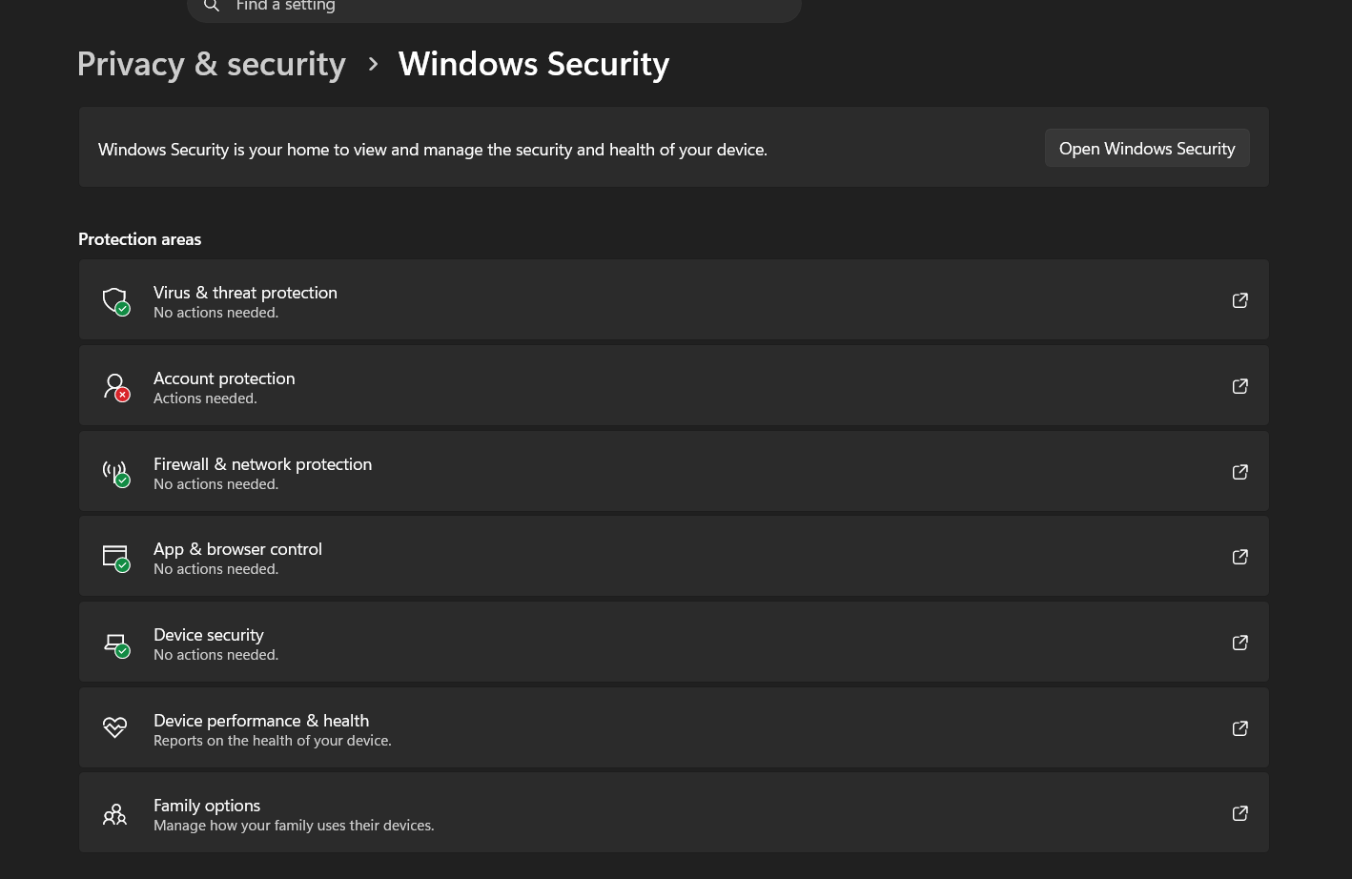
Result:
The Windows Security dashboard displayed the protection status of the system, confirming that the security features were enabled and functioning correctly.

🔹 Task 2: Create a New Windows User Account
Objective: Create a new user account with a strong password.
Steps:
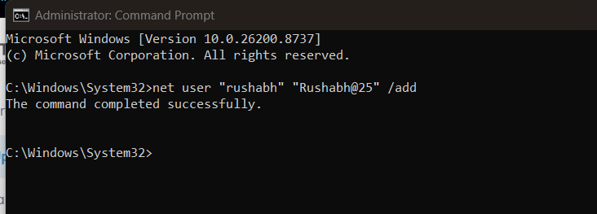
The password meets the following complexity requirements:
- ✔ Uppercase letter
- ✔ Lowercase letter
- ✔ Number
- ✔ Special character
Verification
Sign out and verify that the new account appears on the login screen.
Result:
A new local user account named cyberstudent was successfully created with a strong password.

🔹 Task 3: Disable Public Folder File Sharing
Objective: Disable Public Folder sharing in Windows.
Steps:
- Open Control Panel.
- Go to Network and Sharing Center.
- Click Change Advanced Sharing Settings.
- Expand All Networks.
- Under Public Folder Sharing, select:
  - Turn off Public Folder Sharing
- Click Save Changes.
- From another device on the same network, attempt to access the Public folder to verify that sharing has been disabled.
Verification
The Public folder should no longer be accessible from other devices on the network.
Result:
Public Folder sharing was successfully disabled, preventing unauthorized access from other devices.

🔹 Task 4: Configure Windows Firewall for an Application
Objective: Block all incoming connections for a specific application using Windows Firewall.
Example Application
Google Chrome
Steps:
- Open Windows Security.
- Select Firewall & Network Protection.
- Click Allow an app through Firewall.
- Select Change Settings.
- Locate Google Chrome in the list.
- Uncheck both:
  - Private
  - Public
- Click OK.
Alternative Method (Advanced Security):
- Open Windows Defender Firewall with Advanced Security.
- Select Inbound Rules.
- Click New Rule.
- Choose Program.
- Browse to the Chrome executable:
C:\Program Files\Google\Chrome\Application\chrome.exe
- Select Block the connection.
- Apply the rule to Domain, Private, and Public profiles.
- Name the rule (e.g., Block Chrome) and finish.
Verification
Launch Google Chrome and verify that the application cannot establish network connections according to the configured firewall rule.
Result:
Windows Firewall was configured to block the selected application's network access as specified.

